**Addressing Modes of 8086 Microprocessor**

An instruction performs specific operation on the specified data (operand).Hence the programmer must specify the required data (operand) for an instruction.

The required operand may be placed in the accumulator, in a general purpose register or in a memory location

The different ways in which a source operand is denoted in an instruction is known as **addressing modes**. There are different addressing modes in 8086 programming

am1

Immediate addressing mode

The addressing mode in which the data operand is a part of the instruction itself is known as immediate addressing mode.

Example

MOV CX, 4929 H

ADD AX, 2387 H

MOV AL, FFH

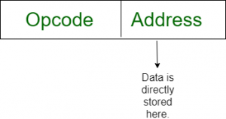

Register addressing mode

It means that the register is the source of an operand for an instruction.

Example

MOV CX, AX ; copies the contents of the 16-bit AX register into

the 16-bit CX register)

ADD BX, AX

ADD AL, BL

am3

Direct addressing mode

The addressing mode in which the effective address of the memory location is written directly in the instruction.

Example

MOV AX, [1592H]

MOV AL, [0300H]

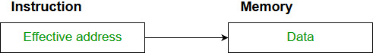

Register indirect addressing mode

This addressing mode allows data to be addressed at any memory location through an offset address held in any of the following registers: BP, BX, DI & SI.

Example

MOV AX, [BX] ; Suppose the register BX contains 4895H, then the

Contents of 4895H memory location are moved to AX

ADD CX, [BX]

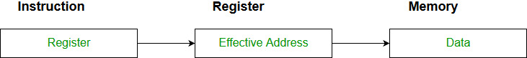

Based addressing mode

In this addressing mode, the offset address of the operand is given by the sum of contents of the BX/BP registers and 8-bit/16-bit displacement.

Example

MOV AL, [BX+05]

MOV DX, [BX+04]

ADD CL, [BX+08]

Indexed addressing mode

In this addressing mode, the operands offset address is found by adding the contents of SI or DI register and 8-bit/16-bit displacements.

Example

MOV BX, [SI+16]

DD AL, [DI+16]

Based-index addressing mode

In this addressing mode, the offset address of the operand is computed by summing the base register to the contents of an Index register.

Example

ADD CX, [AX+SI]

MOV AX, [AX+DI]

Based indexed with displacement mode

In this addressing mode, the operands offset is computed by adding the base register contents. An Index registers contents and 8 or 16-bit displacement.

Example

MOV AX, [BX+DI+08]

ADD CX, [BX+SI+16]

Implied addressing mode

In implied addressing the operand is specified in the instruction itself. In this mode the data is 8 bits or 16 bits long and data is the part of instruction.Zero address instruction are designed with implied addressing mode.

Example:  CLC (used to reset Carry flag to 0)

[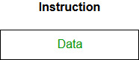](https://media.geeksforgeeks.org/wp-content/cdn-uploads/Addressing_Modes_2.jpg)